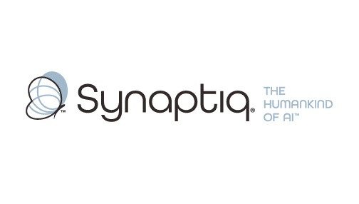
______________________________________________________________________
 | Stephen Sklarew  CEO & Co-Founder, Synaptiq  AI Strategy & Workforce Transformation | "The Humankind of AI"

Overview
Stephen Sklarew is a seasoned executive with over 30 years of experience guiding organizations through transformative AI and technology initiatives, with particular expertise in computer vision deployments across manufacturing and industrial environments. As CEO of Synaptiq, he has led computer vision projects spanning quality control, safety monitoring, and operational efficiency for clients like Skanska (construction site safety), medical device manufacturers, and industrial facilities. His proven AIQ® methodology helps organizations evaluate AI readiness, prioritize high-ROI use cases, and avoid common pitfalls that plague vision initiatives. Stephen combines deep technical understanding with strategic business insight, enabling him to translate computer vision capabilities into measurable outcomes while ensuring sustainable adoption across complex manufacturing operations.
Background & Expertise
Stephen Sklarew is a seasoned business and technology executive with over 30 years of experience driving AI innovation across manufacturing, industrial, and technology-intensive organizations. As CEO and cofounder of Synaptiq, founded in 2015, Stephen specializes in helping established companies navigate complex AI transformations, with particular depth in computer vision applications for manufacturing, quality control, and operational excellence.
Stephen's experience spans the full spectrum of vision technology deployments, from initial feasibility assessment through enterprise-scale implementation. His portfolio includes computer vision projects for construction safety monitoring (Skanska), medical device quality inspection, industrial process optimization, and automated detection systems. This hands-on experience has given him unique insight into the common failure modes of vision initiatives, the critical success factors for ROI achievement, and the organizational capabilities required for sustainable adoption.
Prior to founding Synaptiq, Stephen held senior positions at companies like Sage Software, CEB (now Gartner), and Ernst & Young LLP, where he led technology and operational transformation initiatives across diverse manufacturing and industrial sectors. He also cofounded CircleBack (now SalesIntel) in 2008, a data-driven SaaS platform utilizing machine learning and computer vision for business intelligence.
Under Stephen's leadership, Synaptiq developed the proprietary AIQ® methodology, a comprehensive framework that addresses the organizational, technical, and cultural dimensions of AI readiness. This approach has proven particularly valuable for manufacturing companies launching vision initiatives, as it helps leaders identify high-impact use cases, scope appropriate investments, and build internal capabilities for long-term success. Stephen is committed to ethical AI development and sustainable business outcomes, exemplified by Synaptiq's philosophy of building 'The Humankind of AI' — technology that amplifies human capabilities rather than replacing human judgment.
Stephen regularly shares insights on industrial AI transformation as a thought leader, speaker, and guest lecturer, with particular focus on helping organizations learn from others' successes and failures before making significant technology investments. He holds a BS in Biology from Virginia Tech.
Relevant Experience
- Manufacturing Computer Vision Deployments: Led computer vision implementations for quality control, safety monitoring, and process optimization across industrial environments, including construction sites (Skanska) and medical device manufacturing. Developed frameworks for evaluating vision use cases based on ROI potential and implementation complexity.
- AI Readiness Assessment for Industrial Companies: Created and deployed AIQ® methodology to evaluate organizational readiness for computer vision initiatives, helping manufacturing leaders identify infrastructure gaps, skill requirements, and change management needs before technology deployment.
- Use Case Prioritization and ROI Modeling: Developed systematic approaches for identifying high-impact computer vision applications in manufacturing environments, including cost-benefit analysis frameworks and risk assessment methodologies to guide investment decisions.
- Cross-Industry Vision Technology Transfer: Applied computer vision solutions across healthcare, construction, and industrial sectors, enabling knowledge transfer of successful patterns and failure modes between industries to accelerate implementation and reduce risk.
- Data Strategy for Vision Systems: Designed data infrastructure and governance frameworks to support computer vision initiatives, including image data collection, annotation workflows, model training pipelines, and quality monitoring systems for manufacturing environments.
- Organizational Change for AI Adoption: Guided manufacturing organizations through the cultural and operational changes required for successful computer vision adoption, including workforce training, process redesign, and stakeholder alignment across engineering, operations, and quality teams.

